Linux Servers
Classroom Assignment 5 – Network, routing and NAT
Joni Korpihalkola
Document your commands or take screenshots. Answer questions in english or finnish.
The following assignment uses the same topology and network settings as the Lab1 assignment later on the course. Document all your commands with extra care so you can use them in the Lab1.

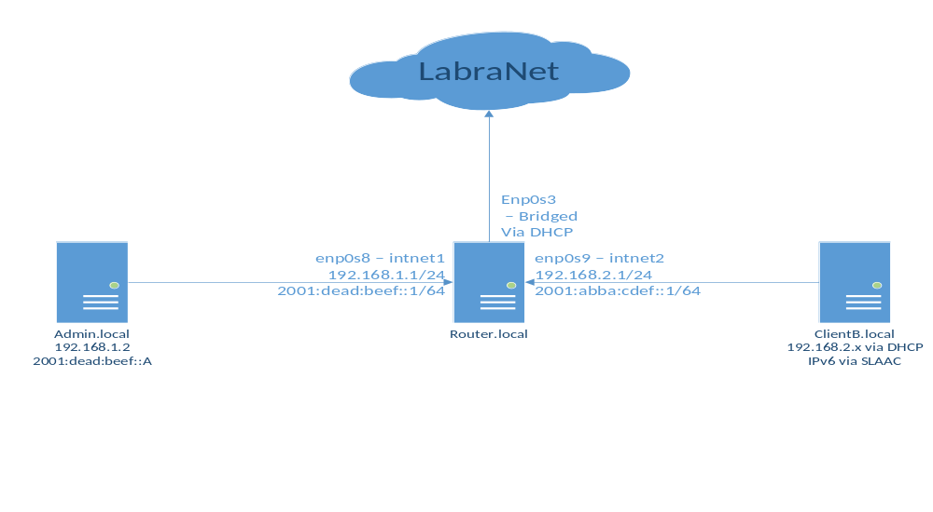

Interfaces
If you haven’t already, configure the VM network interfaces so they match the topology picture. We don’t have DHCP server yet, so you can configure the ClientB with static IP (any IP in the range is okay).
The interface names may not match as they may be enp0s3, ens0 or something else. Check the MAC addresses and compare them to VirtualBox settings. Fix the names in the topology above.
You can configure the IP addresses directly in network-scripts or use nmtui. You can use nmcli if you want to be a badass. But nmtui is much easier. Try to configure at least one interface directly in network-scripts so you have a grasp of how the file works.
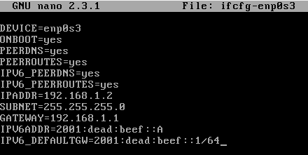

Routing
Set the default gateway for Admin and ClientB (Admin will have 192.168.1.1 as GW). Use the corresponding router interface. DO NOT set the default gateway in the Router side! (why not?)
Admin koneen nmtui asetus
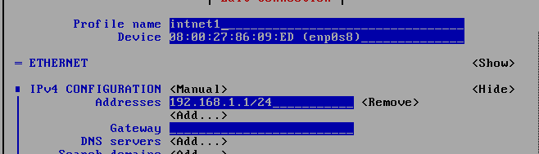
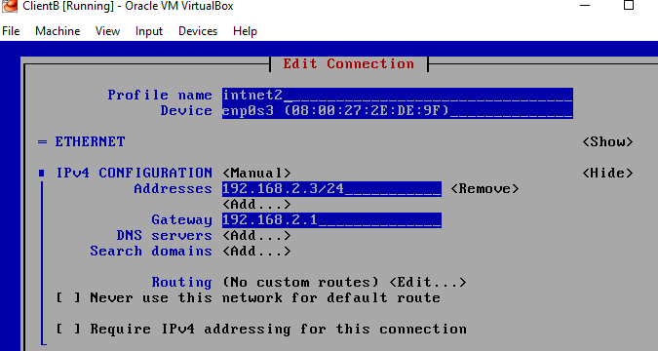
Try to ping everything from everywhere. You should ONLY be able to ping Router from both Admin and ClientB. Why can’t you ping ClientB from the Admin VM, what is missing?
Correct this problem and test that you can now ping each other. Use arp and route –commands if necessary to troubleshoot. Note that you cannot ping LabraNet from Admin or ClientB as you need NAT.

NAT
Configure NAT (masquerade) for the firewalld in Router.local. Note the correct outgoing interface. Try pinging Google DNS (8.8.8.8) or some other Internet resource.
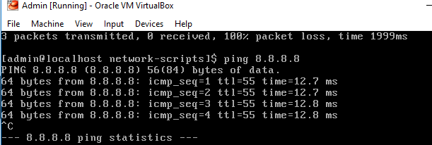
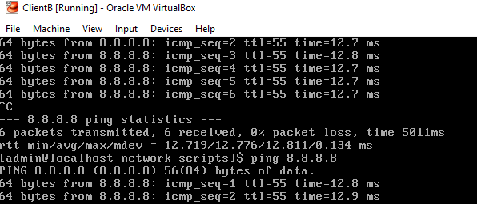
NAT-säätöjen jälkeen Admin ja ClientB-koneilta toimi pingit 8.8.8.8

IPv6
Set IPv6 connectivity between Admin VM and Router as shown in topology picture. The router will have the ip :1 and the Admin VM will have :A. Remember to set the default IPv6 gateway also as :1.
Test connectivity with ping6. If the classroom has IPv6, test pinging some IPv6 address (For example he.net 2001:470:0:76::2 or ftp.funet.fi 2001:708:10:9::20:2). This might be filtered also.

Note: You will not have total connectivity yet as we did not set DNS servers. These will be done in the next assignment, but if you want, you can set them already and test Internet connectivity.
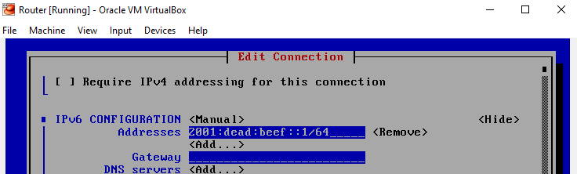
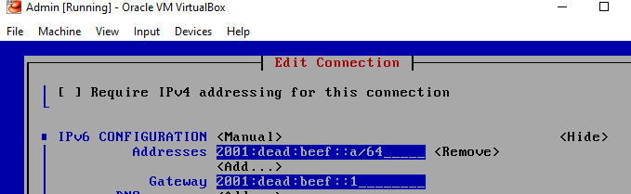
Ping6 toimii admin koneelta routerille

